Log-In Instructions for CITI Program Responsible Conduct of Research Training

Creating an account at CITI Program
- Go to the external website www.CITI Program.org
- Select “Register” if this is your first time logging in. Or select “Log In Through My Organization.”
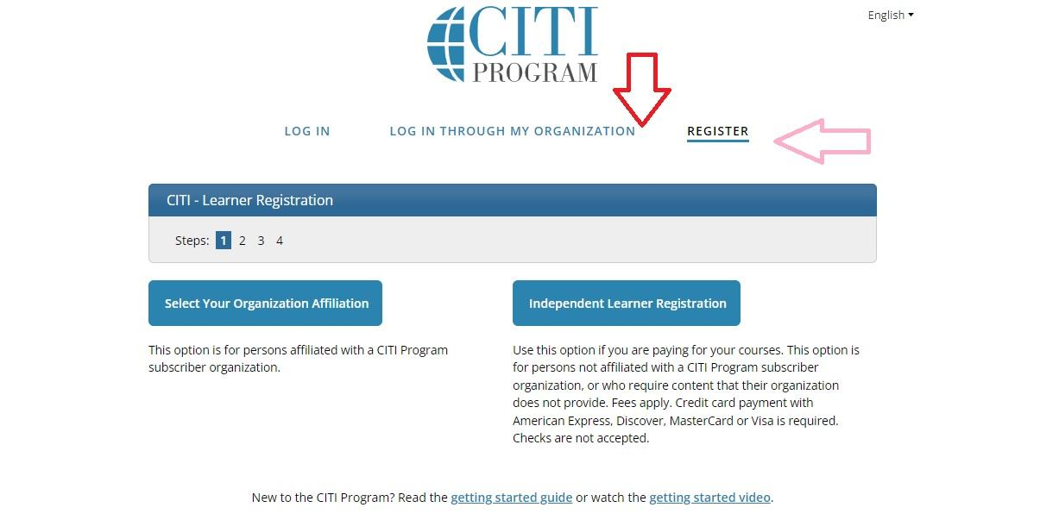
- Select “University of California, Santa Barbara” from Participating Institutions in Step 1.
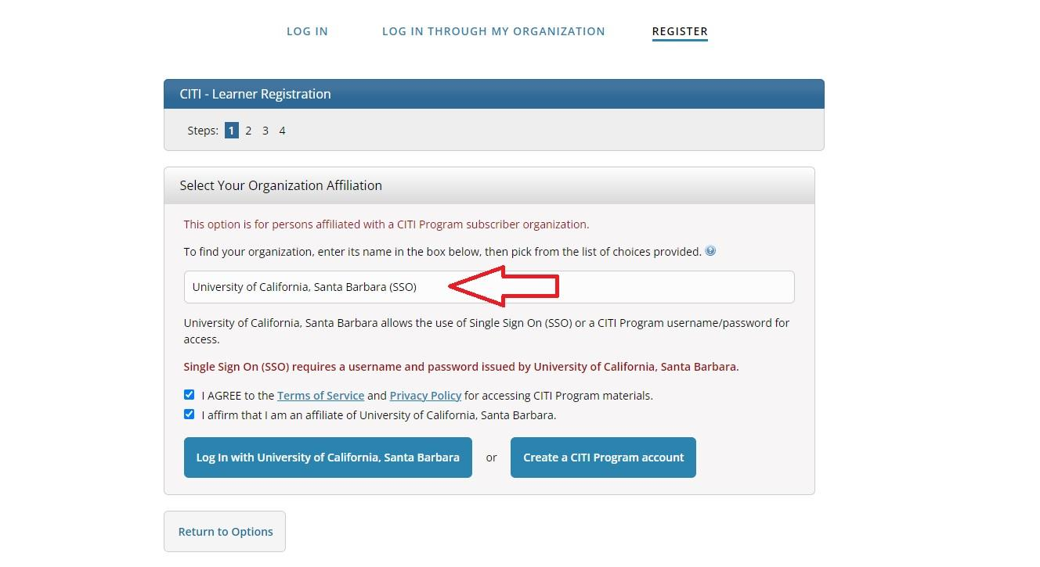
- Log in with your UCSB Net ID and password.
- On the Member Information Page, for “Role in Human Subjects”, choose the field that most closely relates to your research status (disregard the Human Subjects part). For example, if you are an undergraduate working in a laboratory, select “Student Researcher-Undergraduate.” For “Which Course Do You Plan to Take” select “Responsible Conduct of Research.”
- On the Curriculum Page, select the coursework most relevant to your area of research in order to satisfy your training requirements. Choose the Biomedical, Social and Behavioral, Physical Science, or Humanities Responsible Conduct of Research Course. (Choose the course that is most closely related to the work you conduct under your NSF funding.)
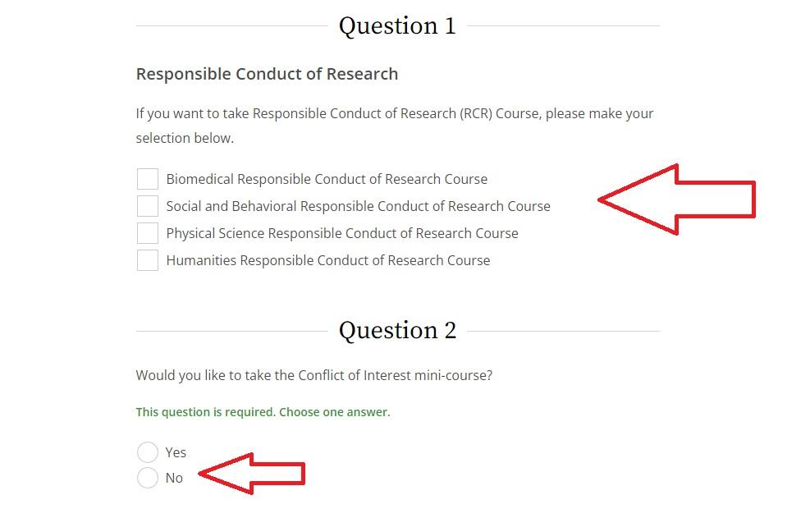
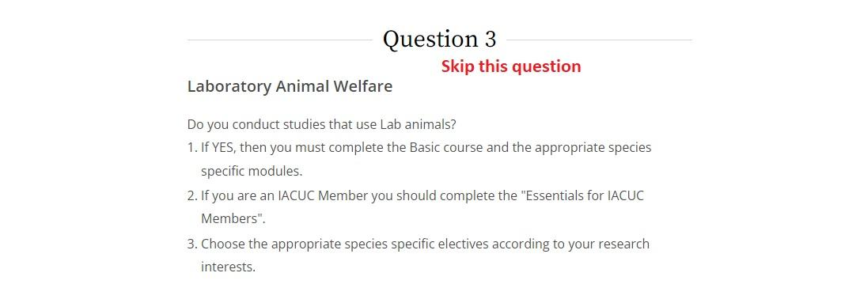
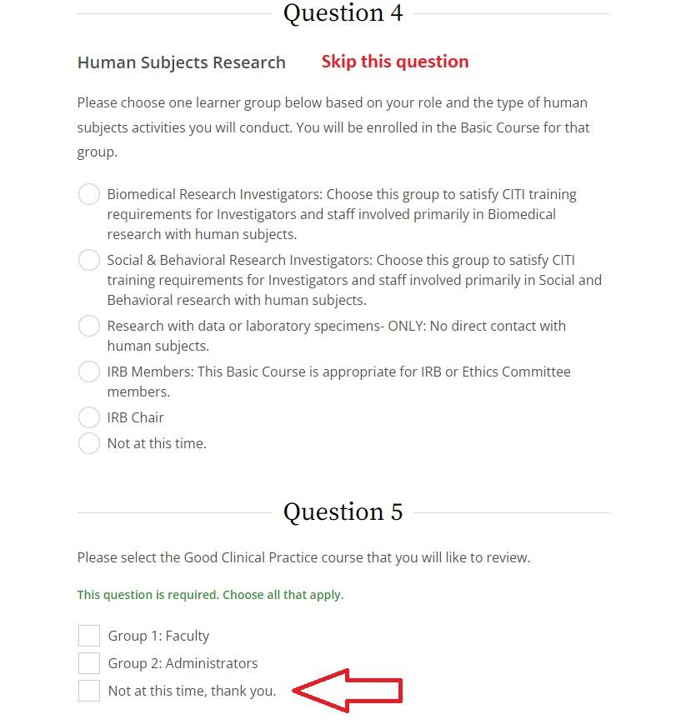

Completing the RCR Training
Once you have completed the series of questions listed above, navigate to My Courses (link at top of page) and select View Courses next to UC Santa Barbara. This will take you to your list of active courses for UCSB. Look for the course that includes “Responsible Conduct of Research Course” in its title. Depending on the type of research activity you selected, the actual title will include that discipline. Here is an example:
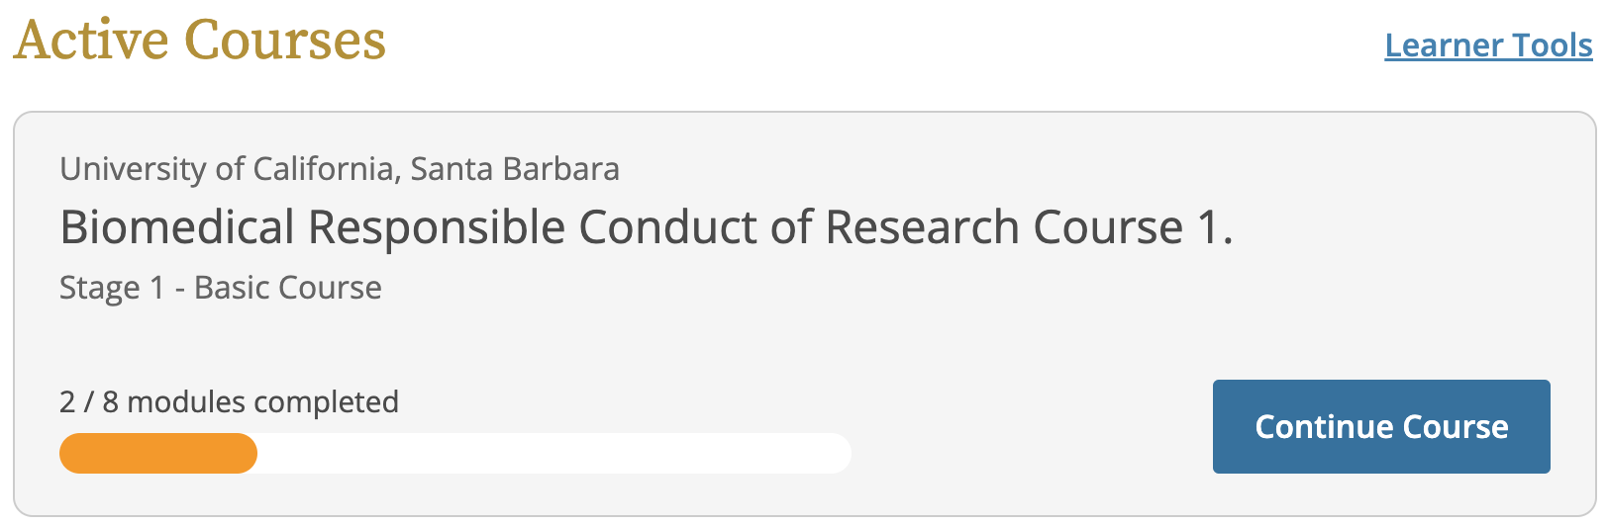

Associating training from a previous institution with UCSB
If you have taken CITI RCR training at another institution, follow these instructions to transfer your completion credit to UCSB:
- Go to the external-based website www.CITI Program.org
- If you have previously completed course work through CITI Program while at another University, you may transfer your completed work to UCSB.
- Log-on as a registered user.
- Once you are on the Main Page, select the red link “Affiliate with another Institution.”
- Select “University of California, Santa Barbara” from the drop-down list of Participating Institutions.
- Once you have completed your affiliation with UCSB on the CITI Program website, email Research Integrity at research-rcr@ucsb.edu with your name and your faculty advisor’s name.

